**Let Credentialing Assistance pay your SANS renewal fees**

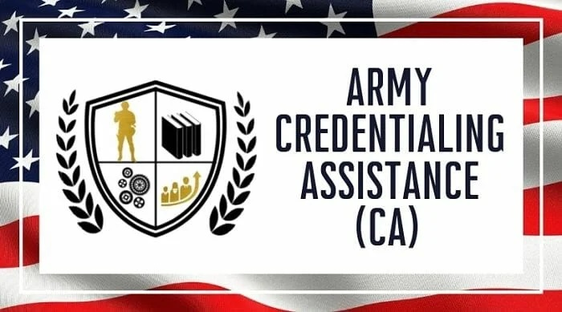

**Background:**

Every four years it is that time again. You are reminded by an email from SANS; you can pay your renewal fee for your certification now. Naturally this renewal fee is per certification, it is not a flat rate membership fee. This distinction quickly becomes painfully clear after a 25D graduates from SLC and has taken perhaps 7 or 8 SANS exams thanks to the Army’s largesse.

You want to keep the SANS certifications current. You don’t want to let the Army’s investment of roughly $8,119 per course & exam combination go to waste. However $1,743 every four years [for 7 certs] is a lot of money for an enlisted guy.

Luckily Credentialing Assistance (CA) comes riding to the rescue here and saves the financial day. Yes, CA will pay your SANS renewal fees. The only limit is $4,000 a year in Tuition Assistance funding. I had heard a rumor that this was possible, but found that the process was not clear. $429 for that first cert’s renewal is a strong motivator though, so I poked around in ArmyignitED until I found it. I got the request submitted but had to go back and knock out some steps out of order while following the helpful advice of an ArmyignitED representative.

Hopefully this step by step walkthrough of the process can save someone that hassle.

**Sidenote:**

I didn’t take good notes the first time through when I renewed GSEC. I was just happy that the process existed and it worked. These notes come from my CA request to renew GCED.

**SANS portal:**

First navigate to [www.sans.org](http://www.sans.org) and login to your account. Hit ‘Certification History’

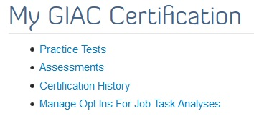

Next scroll down to the cert that you want to renew. If you are putting these CA requests in one after another as soon as you get the auto generated SANS email then there will only be one with the option to renew.

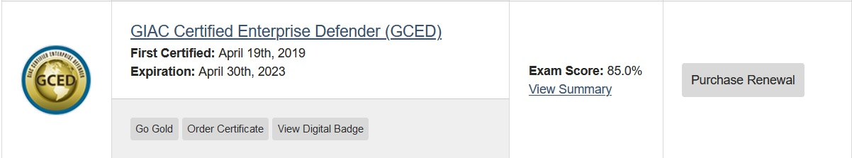

Simply select ‘Renew with CPEs’. There is a separate PowerPoint slide deck on how CPEs work. Please note that this writeup is only regarding the renewal fee.

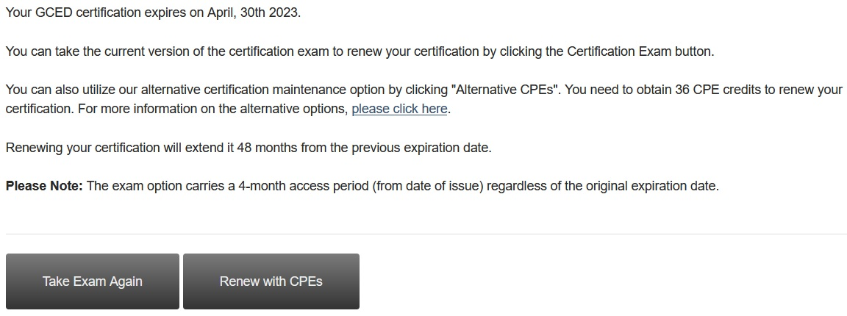

If CA already paid for your GSEC renewal then you will see the discounted price. Just confirm the amount is right.

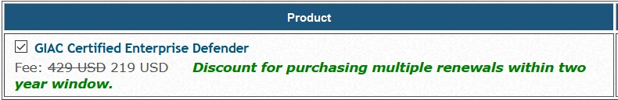

***This part is important!***

Make sure you select ‘Call in Credit Card’ as the payment option after you verify your info. This is the only option that will allow CA to pay. Then hit ‘Review Order’.

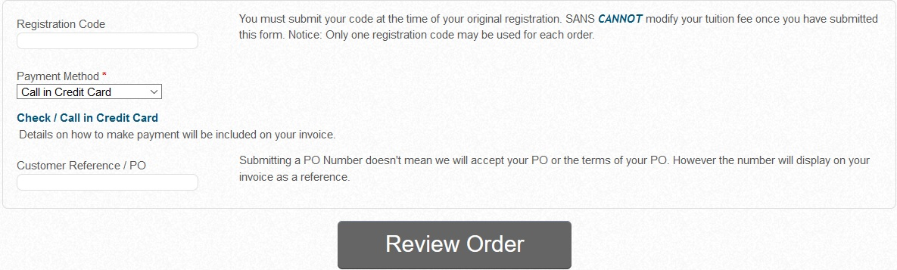

Just verify the amount and hit ‘Place Order’.

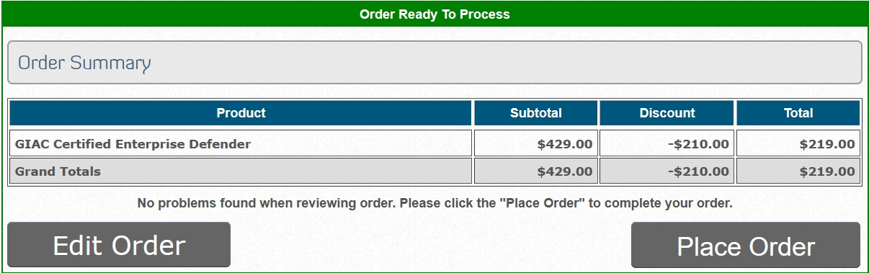

Hit ‘Please print a copy … for your records”. Print to PDF. Save that PDF invoice somewhere handy. It is a vital part of the CA request on ArmyignitED’s portal.

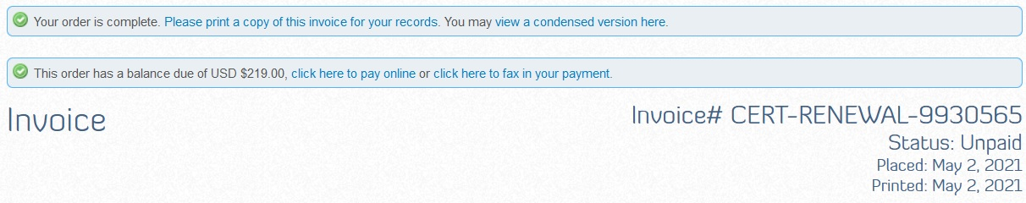

**ArmyignitED:**

Login to ArmyignitED (<https://www.armyignited.com/app/>), navigate to the Credential tab, and hit ‘Add Credential’.

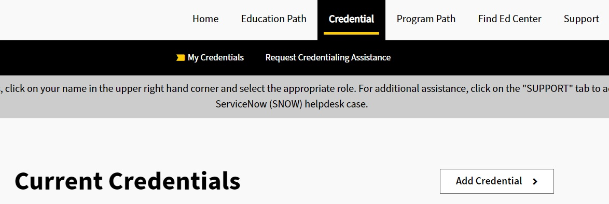

Select that this is for your MOS.

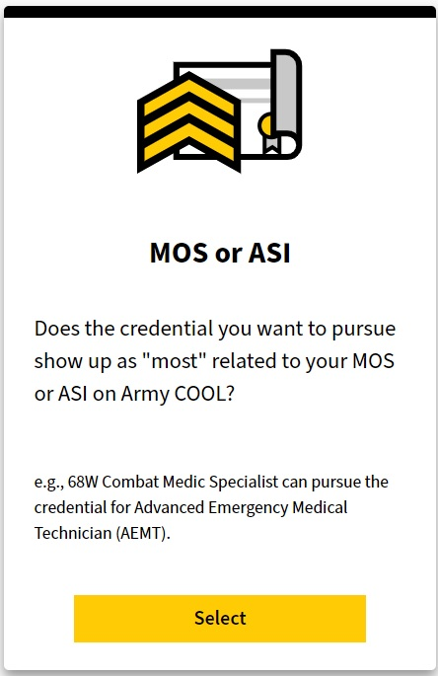

Select your MOS from the drop down and pick ‘New credential’. Yes, pick it. Some of this process is counter-intuitive, hence this walkthrough.

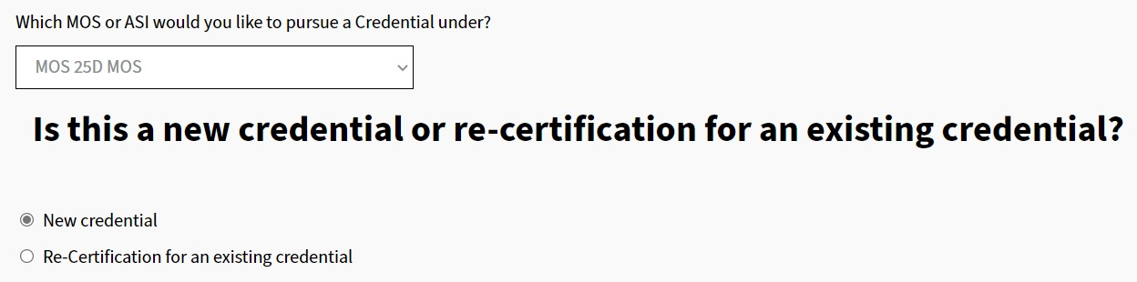

Search “GCED” and select it from the list. Yes, this looks like you are requesting CA to pay for an exam voucher. Like I said, the process is counter-intuitive.

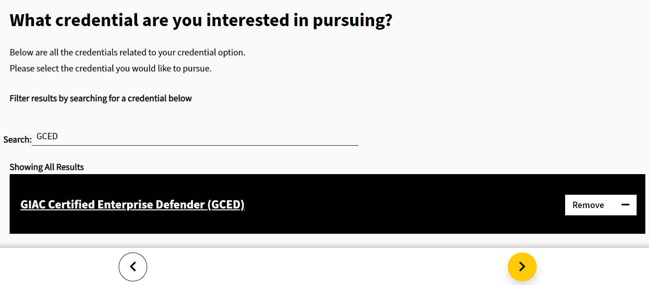

Hit ‘Take credential exam’ and ‘I understand …’.

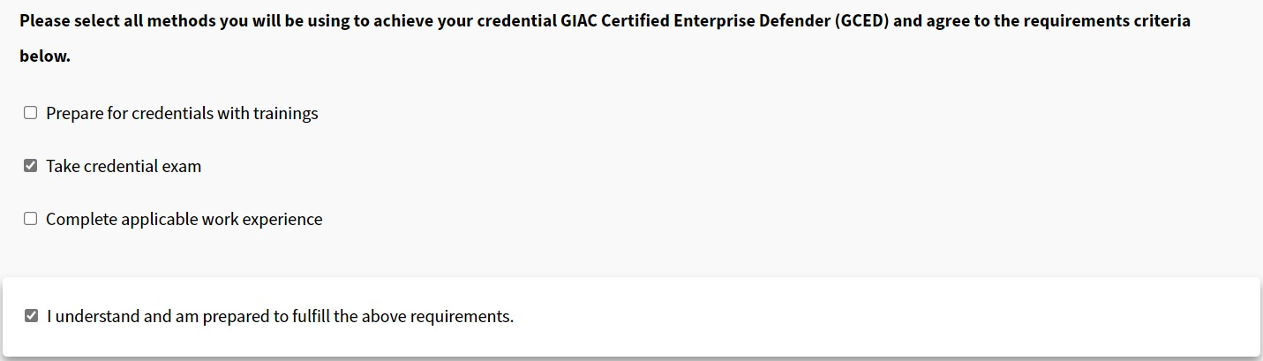

The first leg of the process on ArmyignitED is now done. The process makes more sense after this. On the Credential tab you will now see GCED listed. Hit ‘Request CA’.

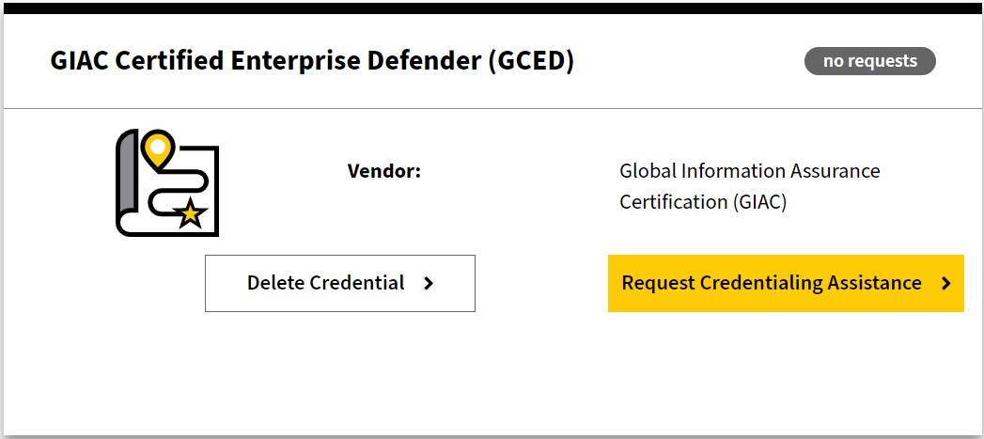

Select GCED from the drop down and hit ‘Request CA’.

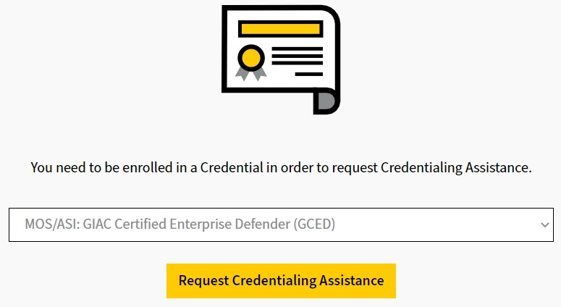

***This part is important!***

Select ‘GCED – Certification Renewal’ and hit next.

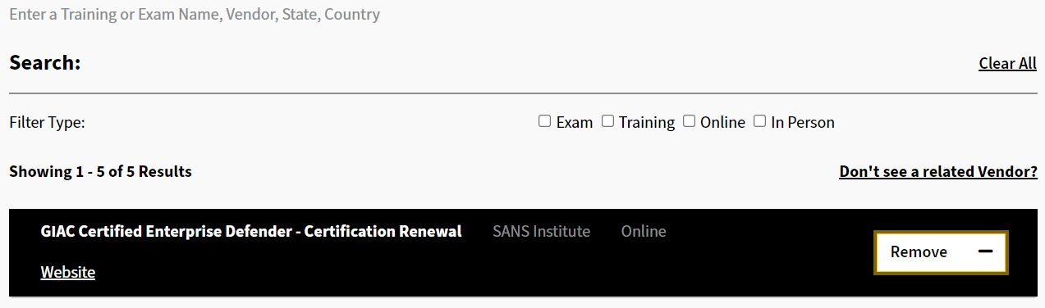

***This part is important!***

Ensure that you scroll down and upload that crucial PDF of the invoice from SANS website. Hit ‘Submit Request’.

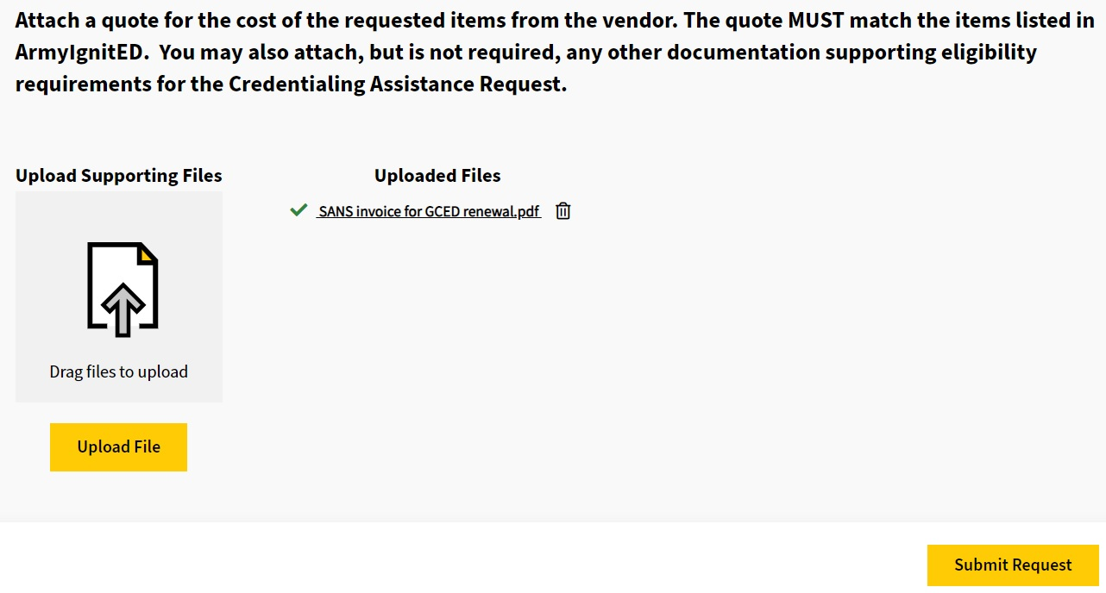

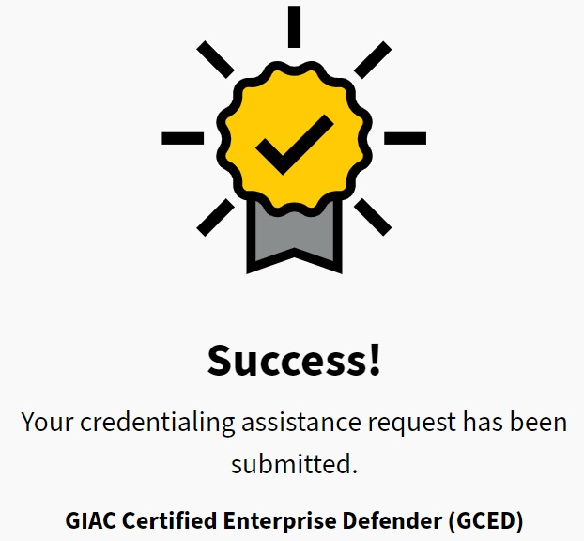

That is it. The processing tends to take about a month on ArmyignitED. Keep an eye on the email you registered when you setup your account. They will email you directly with any issues regarding your request. These emails did not come from a ‘do not reply’ address in my experience and they were very helpful in resolving anything.

You should see an autogenerated email from ArmyignitED once it is sent to finance for payment if your request is a first time go. Within a few days after that you should be able to confirm payment on your SANS account. SANS will also email you to confirm your shipping address for an updated paper copy of the certification. A plaque is of course $25 extra.

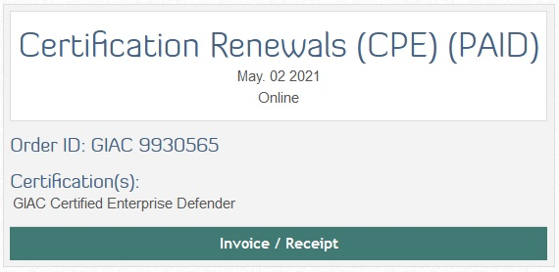

**Wrapping up the CA request:**

Once the SANS & GIAC portals update showing the renewal fee was paid and you have four more years, submit your proof to ArmyignitED. I am still waiting on my new paper copy to show up from SANS, and of course they do not put PDF copies on their site so you can easily save them or print them yourself.

I took screen shots of the parts of the SANS/GIAC portal that show the order was paid and the new expiration date, put them in a PowerPoint slide with a note, and uploaded to ArmyignitED. It’s simple but to the point.

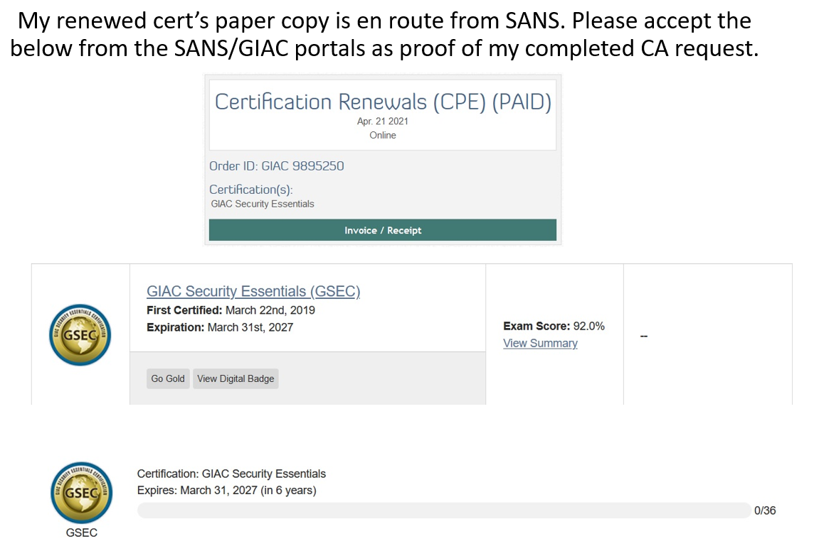

Before anyone asks, the answer is no, GIAC’s portal does not allow you to start uploading CPEs immediately after payment. They make you wait until you are in the next 4 year cycle.

SANS provides access to the updated books and VMs for the class for four months following renewal of the accompanying certification. Don’t forget to go on your SANS account and download the electronic books in PDF format.

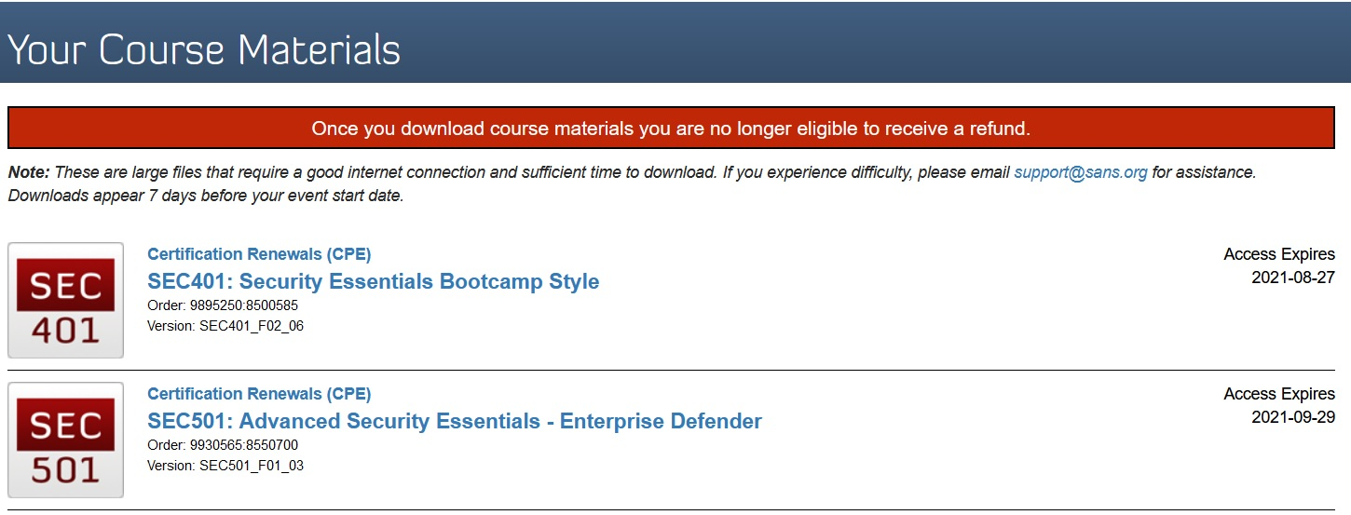

**Conclusion:**

I hope this walkthrough is helpful for someone. I am all for letting CA pay SANS and using my paycheck for mundane things like groceries or the utility bill.

If you read this far and you have any questions, just message me on FB or LinkedIn.

V/R

Richard